

NURail Project ID: NURail2012-UIUC-R01

**Development of a 3D FEM Model for Concrete Tie and Fastening Systems**

By

Bassem O. Andrawes, Ph.D.

Associate Professor

Department of Civil and Environmental Engineering

University of Illinois at Urbana Champaign

Email: andrawes@illinois.edu

and

J. Riley Edwards, P.E.

Senior Lecturer and Research Scientist

Department of Civil and Environmental Engineering

University of Illinois at Urbana-Champaign

E-mail: [jedward2@illinois.edu](mailto:jedward2@illinois.edu)

31 January 2015

Grant Number: DTRT12-G-UTC18

**DISCLAIMER**

Funding for this research was provided by the NURail Center, University of Illinois at Urbana - Champaign under Grant No. DTRT12-G-UTC18 of the U.S. Department of Transportation, Office of the Assistant Secretary for Research & Technology (OST-R), University Transportation Centers Program. The contents of this report reflect the views of the authors, who are responsible for the facts and the accuracy of the information presented herein. This document is disseminated under the sponsorship of the U.S. Department of Transportation’s University Transportation Centers Program, in the interest of information exchange. The U.S. Government assumes no liability for the contents or use thereof.



**TECHNICAL SUMMARY**

**Title**

Development of a 3D FEM Model for Concrete Crosstie and Fastening Systems

**Introduction**

This project conducted detailed finite element (FE) modeling of the concrete crosstie and fastening system to better understand the mechanisms through which loads transfer within various track components in the lateral direction. This was completed by quantifying the following important design and performance parameters:

* What are the loading demands that originate at the wheel-rail interface?
* How is the load transferred to the individual track superstructure components?
* What is the lateral load path within the track system?

**Approach and Methodology**

In the initial stage of this project, critical input and output parameters that serve as guidelines for FE analysis were determined based on existing literature and experience from within the railroad industry. Laboratory and field instrumentation techniques were designed to extract measurements of the critical outputs in the laboratory and field environment, and the FE model was employed to predict responses of the track system.

After the collection of test data, the FE modeling predictions were compared with the experimental data to verify the assumptions and simplifications included in the model. To improve the credibility of the FE models, the model validation was conducted in a hierarchical fashion based on experiments at different levels.

After the validation of models, parametric studies based on the critical inputs and outputs were conducted. In this process the correlation between inputs and outputs were evaluated, and possible alternatives to the current design of concrete crossties and fastening systems were compared. The results of the parametric analyses serve as the basis for the proposed mechanistic design approach.

**Findings**

This project improved our understanding of lateral track load distribution by conducting a thorough review of the literature in this area, especially studies that focused on the modeling the load transfer (path) in railroad track systems.

A direct relation between the single and multiple tie models will be established through the use of the submodeling technique, as a result of this project which, will enable the researchers to correlate the simplified and detailed models at the interfaces where the detailed model is terminated.

The developed multiple-tie model will be utilized in conducting detailed sensitivity study that will aim at understanding the effect of various track components on the distribution of lateral loads between multiple crossties. In the light of the results of the sensitivity study, relationships between the location of the load along the track and the distribution factors will be established.

**Conclusions**

The detailed FE model was validated at multiple levels with manufacturer’s data and experimental data from the laboratory and in the field. The FE model was proven successful in capturing critical mechanisms including the distribution of wheel loads and the flexure of concrete crosstie.

The frictional behavior (frictional force and relative sliding) at the bottom of the rail seat is primarily governed by the interface (i.e. rail-pad interface and plate-concrete interface) with the lowest value of coefficient of friction (COF).

The elastic modulus of the fastening system insulator has little effect on the lateral load path through the fastening system.

Compared to the COF at the rail-pad and plate-concrete interfaces, and the elastic modulus of rail pad, crosstie spacing has a very minimal impact on the performance of the fastening system under lateral wheel load.

The COF at the rail-pad and the plate-concrete interfaces, and the elastic modulus of the rail pad significantly affect the performance of the fastening system under lateral wheel load.

Crosstie spacing significantly affects the distribution of vertical wheel load among multiple rail seats, and the relationship between crosstie spacing and the vertical rail seat load under the point of load application is approximately linear.

**Recommendations**

Historically, North American concrete crosstie and fastening systems have been designed through a process that is generally based on practical experience, without a clear understanding of failure mechanisms, their causes, and the loading environment. This project is a key step toward “Mechanistic Design”. This research provides sophisticated FE modeling tool that can quantify loading at each component of the track system.

The research efforts described in this document represent an initial step toward modeling the detailed loading distribution and transfer in different components within the track system under various loading levels. Implementing the results from this study will provide important insights on component behavior, track design, and track performance optimization.

Additional modeling should be undertaken to continue to understand the expected performance and requested designs of track superstructure components.

**Publications**

Chen, Z., M. Shin, S. Wei, B. Andrawes, D.A. Kuchma. Finite element modeling and validation of the fastening systems and concrete sleepers used in North America, *Proc Inst Mech Eng, Part F: J Rail Rapid Transit* (2014) 0954409714529558

Chen Z, M. Shin, B. Andrawes, J.R. Edwards. Parametric study on damage and load demand of prestressed concrete crosstie and fastening systems. Engineering Failure Analysis. (2014), 46:49–61. Elsevier. doi:10.1016/j.engfailanal.2014.08.002

**Primary Contact**

**Principal Investigator**

Bassem O. Andrawes, Ph.D.

Associate Professor

Department of Civil and Environmental Engineering

University of Illinois at Urbana Champaign

Email: andrawes@illinois.edu

**Co-Principal Investigator**

J. Riley Edwards, P.E.

Senior Lecturer and Research Scientist

Department of Civil and Environmental Engineering

University of Illinois at Urbana-Champaign

E-mail: [jedward2@illinois.edu](mailto:jedward2@illinois.edu)

**Postdoctoral Researcher:**

Moochul Shin

**Graduate Research Assistants:**

Zhe (George) Chen

Austin Zhang

**NURail Center**

217-244-4999

[nurail@illinois.edu](mailto:nurail@illinois.edu)

<http://www.nurailcenter.org/>

TABLE OF CONTENTS

|  |  |
| --- | --- |
| LIST OF FIGURES……………………………………………………………………………........ | viii |
| LIST OF TABLES…………………………………………………………………………………. | xi |
| SECTION 1. INTRODUCTION…………………………………………………………………… | 1 |
| 1.1 Background and Motivation…………………………………………………………………… | 1 |
| 1.2 Study Objectives………………………………………………………………………………. | 1 |
| SECTION 2 MODELING DEVELOPMENT……………………………………………………… | 2 |
| 2.1 Critical Input and Output Parameters…………………………………………………………. | 2 |
| 2.2 Modeling of Concrete Crosstie, Fastening System, and Wheel………………………………. | 4 |
| 2.3 Single-Tie Model, Multiple-Tie Model, and Dynamic Model………………………………… | 7 |
| SECTION 3 PARAMETRIC STUDIES OF CRITICAL DESIGN PARAMETERS……………… | 10 |
| 3.1 Parametric Studies Matrix……………………………………………………………………... | 10 |
| 3.2 Preliminary Parametric Study of the Frictional Interaction and Behavior of the Fastening  System and its Components…………………………………………………………………… | 11 |
| 3.3 Determination of Critical Input Interaction…………………………………………………… | 14 |
| SECTION 4. CONCLUSIONS…………………………………………………………………….. | 16 |
| 4.1 Summary………………………………………………………………………………………. | 16 |
| 4.2 Future Research Directions……………………………………………………………………. | 16 |
| REFERENCES……………………………………………………………………………………… | 17 |

LIST OF FIGURES

|  |  |
| --- | --- |
| Figure 1. Illustration of Frictional Interface Locations……………………………………………... | 3 |
| Figure 2. Schematic of the Fastening System Model………………………………………………. | 5 |
| Figure 3. Components of the Fastening System: (a) Clip, (b) Shoulder, (c) Insulator, and (d) Rail  Pad…………………………………………………………………………………………………. | 5 |
| Figure 4. Engineering Drawing for the Concrete Crosstie Simulated in the FE Model……………. | 6 |
| Figure 5. Configuration of 3D Concrete Crosstie, Rail, Fastening System, and Substructure FE  Models……………………………………………………………………………………………... | 6 |
| Figure 6. (a) PLTM Test Setup (Loading Head), and (b) PLTM FE Model ………………………. | 7 |
| Figure 7. (a) SLTM Test Setup, and (b) Symmetric SLTM FE Model…………………………….. | 7 |
| Figure 8. Field Test Setup using the Track Loading Vehicle (TLV) and Simplified Multiple-Tie  FE Model…………………………………………………………………………………………... | 8 |
| Figure 9. Submodeling of Track Structure to Represent Field Conditions….……………………… | 9 |
| Figure 10. Profile View of 43-Crosstie Dynamic Model Setup……………………………………. | 9 |
| Figure 11. Illustration of FE Model Output in the Parametric Study: a) Shoulder Bearing Force  and Rail Pad Friction Force at the Loaded Rail Seat and b) Rail Head Lateral Deflection……….. | 11 |
| Figure 12. Results of Single-variable Parametric Analysis of a) Shoulder Bearing Force, b) Rail  Pad Friction Force and c) Rail Head Lateral Deflection…………………………………………... | 12 |
| Figure 13. Results From Two-variable Parametric Studies Focusing on a) Shoulder Bearing  Force, b) Rail Pad Friction Force, and c) the Rail Head Lateral Deflection………………………. | 13 |

LIST OF TABLES

|  |  |
| --- | --- |
| Table 1. Critical Modeling Inputs ………………………………………………………………….. | 2 |
| Table 2. Critical Friction Input……………………………………………………………………... | 3 |
| Table 3. Critical Modeling Output………………………………………………………………….. | 4 |
| Table 4. Design of the Parametric Study of Critical Design Parameters…………………………… | 10 |
| Table 5. Design of Preliminary Parametric Study on Frictional Interaction……………………….. | 11 |
| Table 6. ANOVA Results for Three Loading Scenarios……………………………………………. | 15 |

SECTION 1 INTRODUCTION

* 1. *Background and Motivation*

It is understood among researchers and practitioners in the railroad industry that interaction between components plays significant role in defining the safety and serviceability of railroad track systems. With the increasing interest in replacing timber crossties with concrete crossties, there is a dire need to understand better the interaction between multiple concrete crossties especially under lateral loading. This relates specifically to the USDOT’s strategic coal of “State of Good Repair” as well as “Safety” given the implications of failure to restrain the rail laterally. Understanding lateral load distribution mechanism and its controlling parameters will allow engineers to optimize the distribution of loads, which will directly optimize the level of lateral load transferred to each tie and it fastening system. This will protect both crossties and fastening system from excessive deterioration, which had proven to have significant negative implications on the long-term safety and serviceability (state of repair) of railway infrastructure.

* 1. *Study Objectives*

The primary objective of this project is to study and better understand the mechanisms through which the loads transfer within various track components in the lateral direction. It is well known that the mechanism of load transfer in the lateral direction is fundamentally different from that of the loads in the vertical direction. In the lateral direction, the fastening system along with the ballast interactions with the crossties play significant roles. This project will aim at capitalizing on the advances in the Finite Element Analysis (FEA) efforts developed over the last couple years by the PI and his group to model crossties and fastening systems. Finite element method will be utilized in this project to study the interaction of multiple crossties while considering the impact of the fastening system components. Due to the complexity of the problem and to avoid very expensive time of computational runs, the technique of ‘submodeling’ will be adopted. This technique will enable the researchers to capture the influence of various track components (including multiple ties) with significant reductions in the time of problem solving. The study will focus on understanding the factors affecting the distribution of lateral loads and how track conditions and mechanical properties could possibly affect these factors. Recommendations will be developed on the selection of material and geometric properties of fastening system components to satisfy optimum load distribution requirements.

SECTION 2 MODEL DEVELOPMENT

* 1. *Critical Input and Output Parameters*

The critical inputs and outputs of the FE models were determined based on the Federal Railroad Administration (FRA) Track Safety Standards Compliance Manual, research work published by peers, and engineering judgment of industrial partners with field experience. **Table 1** summarizes the critical input list of the FE models and **Table 2** includes supplementary explanations for the input frictional behavior parameters. The location of the interaction definition for coefficient of friction (COF) is shown in **Figure 1**. In addition, **Table 3** shows a summary list of output parameters of the FE models. The definition for the critical model outputs are listed in the appendix. In **Table 1** and **Table 2** the critical inputs are classified based on the component that they are related to. Although the focus of this research was the concrete crosstie and fastening system, the modeling of the rail and substructure was also included in the analysis as they are closely related to the performances of the system. The rail was defined according to its actual cross section (136 RE rail) and material properties, while the track substructure was simplified into a general support layer. The stiffness of the support layer was calibrated based on field displacement measurements, and it represented the system behavior of multiple support layers.

Table 1. Critical Modeling Inputs

|  |  |  |  |  |
| --- | --- | --- | --- | --- |
| **Component** | **Input** |  | **Component** | **Input** |
| Load | Vertical loading |  | Abrasion Frame | Young's modulus |
| Lateral loading |  | Frame geometry |
| Rail | Rail geometry |  | Shoulder | Young's modulus |
| Location of contact patch |  | Shoulder geometry |
| Young's modulus |  | Yielding strength |
| Insulator | Insulator geometry |  | Reinforcement | Prestress force |
| Yielding strength |  | Young's modulus |
| Young's modulus |  | Strand diameter |
| Clip | Young's modulus |  | Strand distribution |
| Yield strength |  | Number of reinforcement |
| Crosstie | Compressive strength |  | Support | Track modulus |
| Tie spacing |  | Rail Pad | Young's modulus |
| Geometry of crossties |  | Pad geometry |
| Bond-slip behavior |  | Poisson's ratio |
|  | Wheel | Acceleration |

Table 2. Critical Friction Input

|  |  |  |
| --- | --- | --- |
| **Component** | **Frictional Interaction** | **COF** |
| Pad | Pad-frame interface | 0.3 |
| Pad-rail interface | 0.3 |
| Abrasion Frame | Frame-concrete interface | 0.3 |
| Insulator | Insulator-rail interface | 0.15 |
| Insulator-clip interface | 0.15 |
| Insulator-shoulder interface | 0.15 |
| Shoulder | Shoulder-clip interface | 0.5 |
| Crosstie | Crosstie-ballast interface | 0.7 |
| Wheel | Wheel-rail interface | 0.5 |

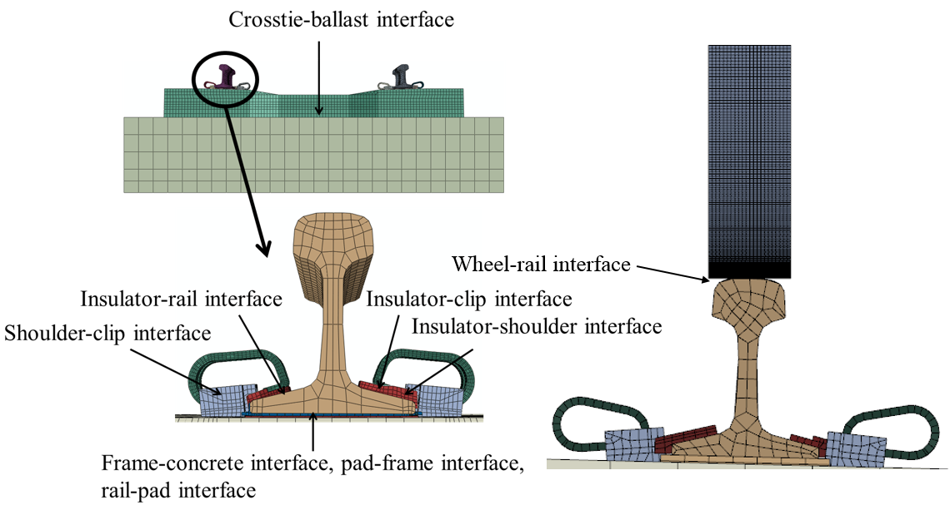

Figure 1. Illustration of Frictional Interface Locations

Table 3. Critical Modeling Output

|  |  |
| --- | --- |
| **Critical Modeling Output** | |
| Track vertical deflection | Rail base rotation |
| Track lateral deflection | Shoulder bearing force |
| Rail-base lateral displacement | Rail pad frictional force |
| Abrasion frame lateral translation | Crosstie rail-seat moment |
| Vertical rail-seat load | Crosstie center moment |
| Lateral rail-seat load | Vertical rail-seat load at adjacent crossties |
| Gauge-side clamping force | Lateral rail-seat load at adjacent crossties |
| Field-side clamping force | Relative sliding between rail and rail pad |
| Maximum rail-seat pressure | Relative sliding between abrasion frame and rail seat |
|  |  |

* 1. *Modeling of Concrete Crosstie, Fastening System, and Wheel*

Various designs of fastening systems and prestressed concrete crossties have been placed in revenue service in North America. Modeling every possible combination of fastening system and concrete crosstie would be impractical. Therefore, the UIUC model focused on a prevalent type of concrete crosstie and fastening system in North America, the Safelok I system (**Figure 2**). As shown in **Figure 2**, the fastening system is cast into the concrete crosstie to transmit wheel load from the rail to the concrete and maintain uniform track geometry. The fastening system modeled herein includes embedded cast iron shoulders, rail clips, nylon insulators, and a rail pad assembly consisting of a polyurethane rail pad for load attenuation and a nylon 6/6 abrasion frame to mitigate abrasion of the concrete. Rail clips are assembled into the shoulder with initial deformation, and the resulting clamping force prevents longitudinal and lateral displacements of the rail. Insulators were placed between the clip and the rail to insulate the two rails electrically. When modeling the components of the fastening system, the geometries of the components were simplified. **Figure 3** shows FE models of the individual fastener components in the isometric view.

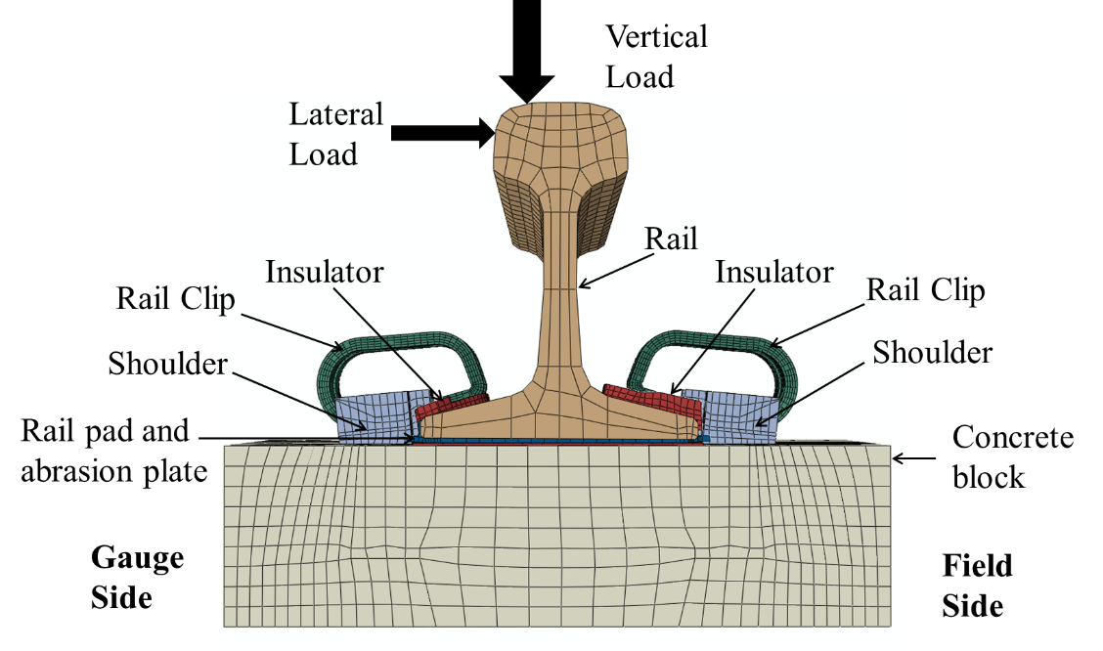

Figure 2. Schematic of the Fastening System Model

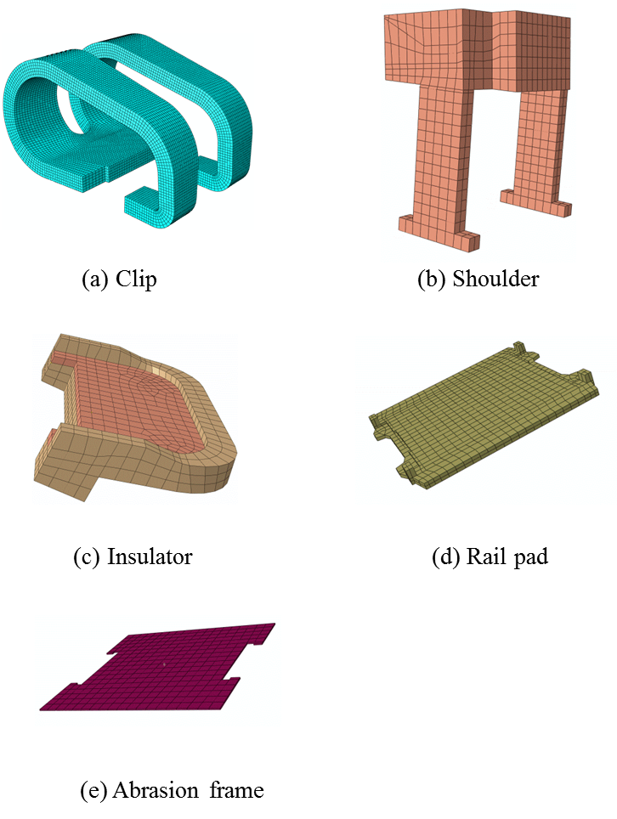

Figure 3. Components of the Fastening System: (a) Clip, (b) Shoulder,   
(c) Insulator, and (d) Rail Pad

The engineering drawings of the concrete crosstie included in the FE model are shown in **Figure 4**. **Figure 5** shows a single prestressed concrete crosstie model with fastening systems assembled on each rail seat. The dimensions of the crosstie are 102 in (length) x 11 in (width) x 9.5 in (height). Twenty steel wires of 0.21 in diameter are embedded in the crosstie to provide prestressing forces.

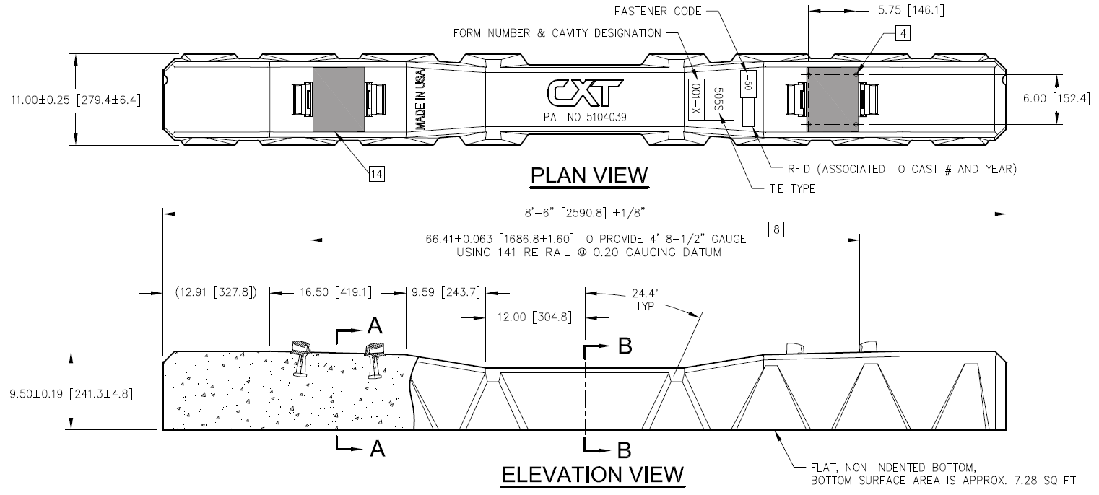

Figure 4. Engineering Drawing for the Concrete Crosstie Simulated in the FE Model

fig3

Figure 5. Configuration of 3D Concrete Crosstie, Rail,   
Fastening System, and Substructure FE Models

* 1. *Single-Tie Model, Multiple-Tie Model, and Dynamic Model*

Single-tie models and multiple-tie models were developed to accomplish multiple objectives. Two types of single-tie models have been built according to the settings of laboratory experiments, and they were used to investigate the vertical and lateral load paths through the system, and the demand on each component. **Figure 6** and **Figure 7** show the two single-tie models for the following laboratory experiments: Pulsating Load Testing Machine (PLTM) experimentation and Static Load Testing Machine (SLTM) experimentation. At a given loading condition, responses such as the lateral displacement of railhead, vertical displacements of the rail base, web strains of the rail, and strains of the clip surfaces were compared. The Portable Track Loading Frame (PTLF) was used to apply known lateral load, and the PLTM was used to apply a controlled vertical and lateral load with a specific L/V ratio.

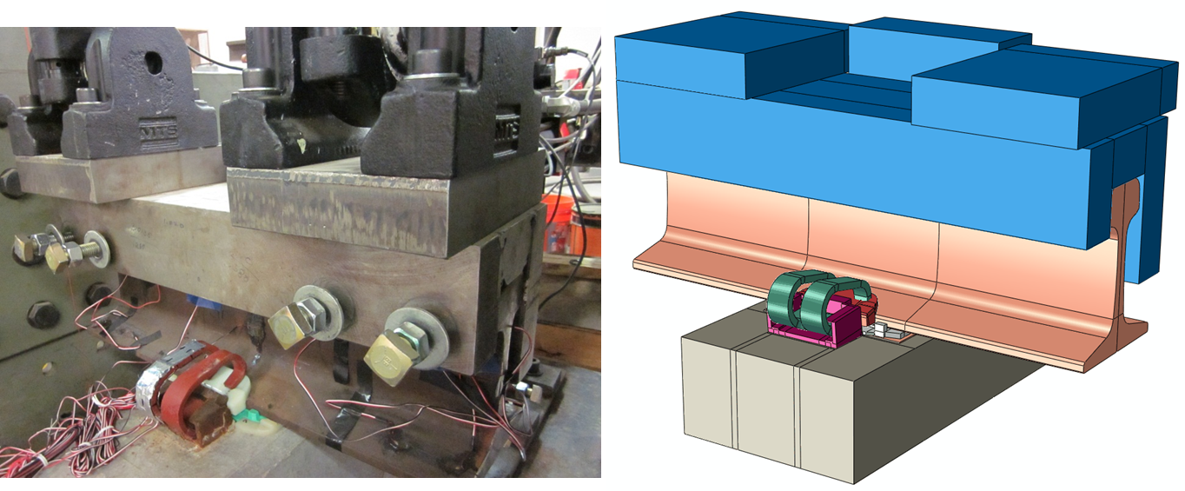

**(a) (b)**

Figure 6. (a) PLTM Test Setup (Loading Head), and (b) PLTM FE Model

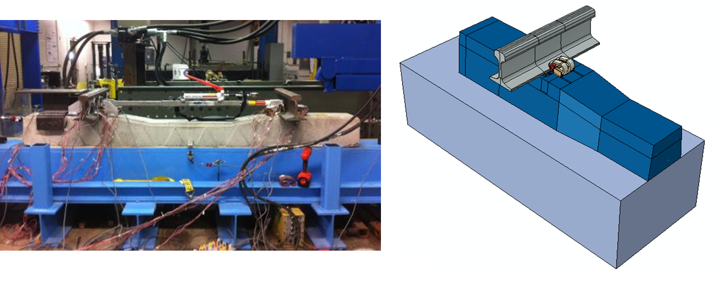

1. **(b)**

Figure 7. (a) SLTM Test Setup, and (b) Symmetric SLTM FE Model

In order to accurately simulate the track structure in the field, a multiple-tie model was developed, and **Figure 8** shows the developed multiple-tie model. One of the key features related to modeling the track structures in the field is to incorporate realistic support conditions. The simulation results were validated with various measurements collected from field tests conducted at Transportation Technology Center, Inc. (TTCI) in Pueblo, CO.

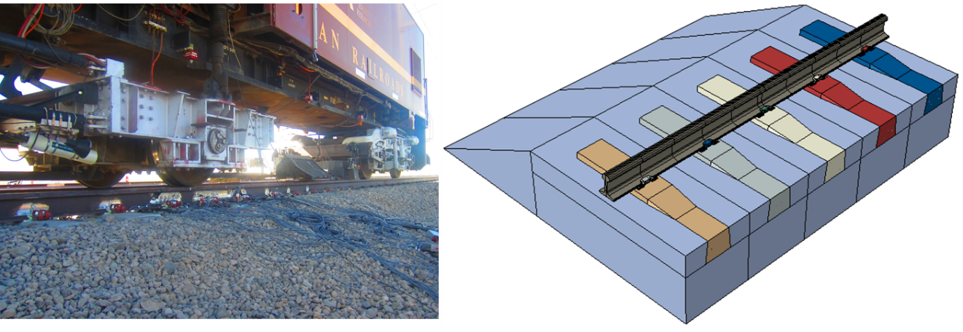

Figure 8. Field Test Setup using the Track Loading Vehicle (TLV) and   
Simplified Multiple-Tie FE Model

The multiple-tie model is computationally expensive, and it is not computationally efficient to use the multiple-tie model to run the parametric analyses. Submodeling is an alternative modeling technique to simulate the track structure with a global model and a detailed model. **Figure 9** shows a diagram of the submodeling approach. In the detailed model that includes the single crosstie and fastening system, the boundary conditions applied at each end of the rail was extracted from the global track model. The global model was calibrated based on the field test results to represent the support conditions of the testing track section. The rail displacement in the global model served as the boundary condition in the detailed single-tie model, which was used for system parametric studies.

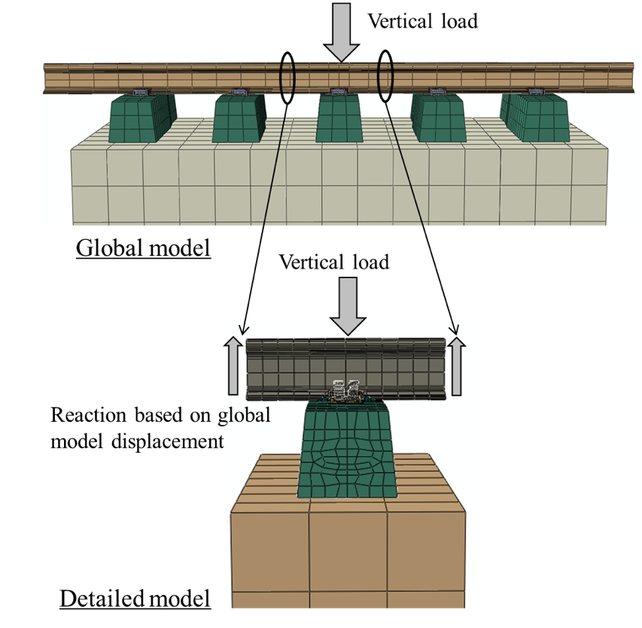

Figure 9. Submodeling of Track Structure to Represent Field Conditions

The dynamic model was developed based on the multiple-tie FE model. The intention of the model is to provide insight into the longitudinal load distribution among multiple rail seats and load path under dynamic wheel loads. The length of the dynamic model was modified several times during its development so that the length was sufficient for the longitudinal load to dissipate among rail seats. The finalized dynamic model consisted of 43 crossties with 24-inch spacing, resulting in a total track length of 86 feet. As the major computational demand was caused by the dense mesh of the rail and wheel, the rail section with refined mesh only extended over seven rail seats located at the center of the track. The segments of rail connected to the center segment were modeled with coarse elements to reduce computational time. **Figure 10** shows a profile view of the track that was used for the dynamic model.

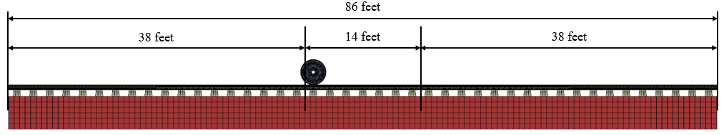

Figure 10. Profile View of 43-Crosstie Dynamic Model Setup

SECTION 3 PARAMETRIC STUDIES OF CRITICAL DESIGN PARAMETERS

* 1. *Parametric Studies Matrix*

To investigate the effect of and interaction between a subset of critical design parameters on the performance of the concrete crosstie and fastening system, the field-validated FE model was used to execute a series of parametric studies. The design of parametric study is summarized in **Table 4**.

Three loading scenarios were considered to simulate the loading conditions on curved track with varying degrees of curvature. Considering a 315 kip gross rail load (GRL) rail car with a vertical wheel load of 40 kips, a variable lateral wheel load was defined for each of the three loading scenarios. The coefficient of friction (COF) at the rail-pad interface and plate-concrete interface were combined and is discussed in detail in the following section. The ranges of input parameters were determined based on reference about tribology and polymer material property (Yamaguchi 1990, Hepburn 1982, Harper 1996) and conversations with experts in track component engineering. The same input and output parameters were studied under different loading scenarios, and the parameters that were not included in list of inputs were held constant at the same level that was observed in our field experimentation. Examples of constant parameters were track substructure stiffness and crosstie prestressing strand distribution. The definitions of output are shown in **Figure 11**. To evaluate the interactions of the design parameters (i.e. input) that were potentially significant, the parametric study was divided into two phases for each loading scenario. In the first phase, a full factorial design of cases was generated at reasonable maximum and minimum values of the design space. Based on the FE model output, an analysis of variance (ANOVA) was used to determine the interaction of design parameters that are statistically significant. In the second phase of this work, more cases were generated to further investigate significant input interactions.

Table 4. Design of the Parametric Study of Critical Design Parameters

|  |  |  |  |
| --- | --- | --- | --- |
|  | | Range | Base value |
| **Input** | Crosstie spacing (in) | 20~30 | 24 |
| Rail-pad and plate-concrete COF | 0.12~1.0 | 0.3 |
| Pad elastic modulus (psi) | 4,000~400,000 | 7,500 |
| Insulator elastic modulus (psi) | 400,000~2,000,000 | 440,000 |
| **Output** | Rail head lateral displacement |  | |
| Shoulder bearing force at the loaded rail seat |
| Pad friction force at the loaded rail seat |
| Vertical rail seat load |
| **Loading scenarios** | Loading scenario 1: V=40 kips, L=10 kips |
| Loading scenario 2: V=40 kips, L=20 kips |
| Loading scenario 3: V=40 kips, L=30 kips |

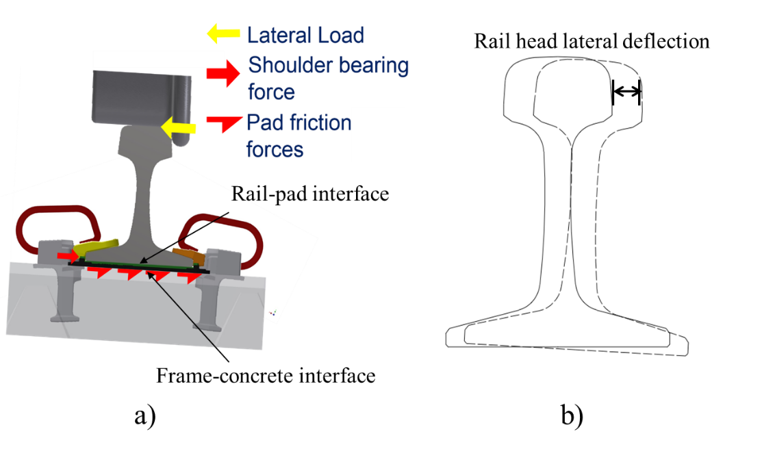

**Figure 11. Illustration of FE Model Output in the Parametric Study: a) Shoulder Bearing Force and Rail Pad Friction Force at the Loaded Rail Seat and b) Rail Head Lateral Deflection**

* 1. *Preliminary Parametric Study of the Frictional Interaction and Behavior of the Fastening System and its Components*

Before the comprehensive parametric study was performed, the field-validated FE model was used in a preliminary parametric study of the effect of frictional interactions in the fastening system on the lateral load path. The COF at the rail-pad interface and the plate-concrete interface were used as input variables, and select outputs related to the fastening system performance under lateral wheel loads were extracted, as shown in **Table 5**. A vertical wheel load of 40 kips and a lateral wheel load of 20 kips was used for all cases.

Table 5. Design of Preliminary Parametric Study on Frictional Interaction

|  |  |  |  |
| --- | --- | --- | --- |
|  | | Range | Base value |
| **Input** | Pad-rail COF | 0.12～1.00 | 0.3 |
| Frame-concrete COF | 0.15～1.00 | 0.3 |
| **Output** | Rail head lateral displacement |  | |
| Shoulder bearing force at the loaded rail seat |
| Pad friction force at the loaded rail seat |
| **Loading scenario** | V=40 kips, L=20 kips | | |

Two sets of cases were generated to investigate the effect of rail-pad COF and frame-concrete COF on the performance of the fastening system under lateral wheel loads. In the first set, one COF varied within the defined range, and the other COF remained at the default value (single-variable cases). In the second set, both COF at the two interfaces were varied to evaluate their interaction (two-variable cases). The result of single-variable cases is summarized in **Figure 12**. In each figure, the two lines represented the cases in which rail-pad or frame-concrete COF was the variable, and the other COF remained constant. In **Figure 12**, it can be observed that within a range, the rail pad frictional force increased with higher COF, and both the shoulder bearing force and rail-head lateral deflection decreased with higher COF. At higher COF the model output was not as sensitive to the change in COF. In all cases, the threshold COF value for the sensitivity of system response was 0.3, which was the default value of the COF at the two interfaces. In addition, identical response of the shoulder bearing force, rail pad frictional force, and rail head lateral deflection was observed when the varying COF was at the same magnitude.

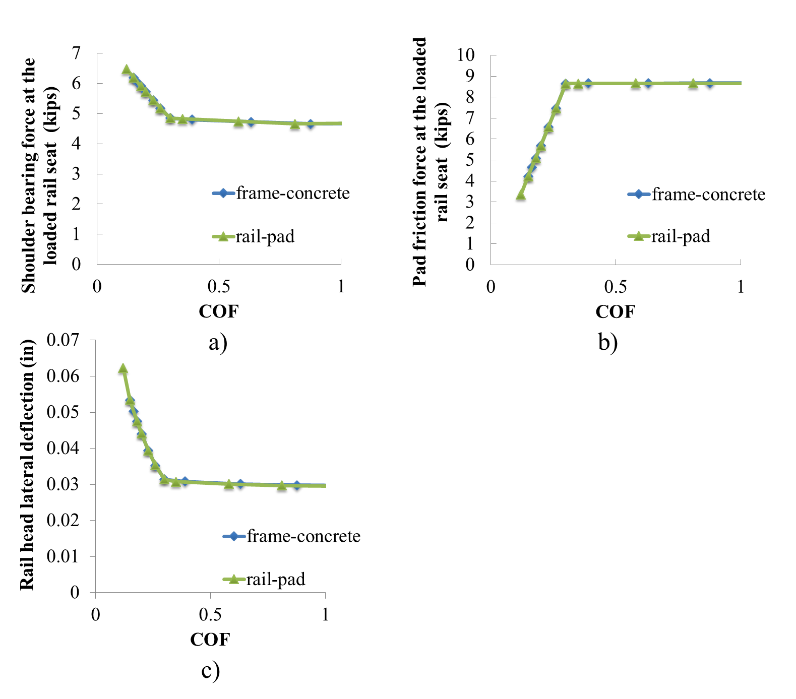

Figure 12. Results of Single-variable Parametric Analysis of a) Shoulder Bearing Force,   
b) Rail Pad Friction Force and c) Rail Head Lateral Deflection

Under lateral wheel loads, the relative sliding between rail base and concrete could be divided into three parts: 1) the relative sliding between rail and the rail pad, 2) between the abrasion plate and concrete, and 3) the shear deformation of the entire rail pad assembly. As the rail pad was embedded into the abrasion plate, the relative sliding between the rail pad and abrasion plate was assumed to be insignificant. The COF at the two interfaces served as the threshold for the linear friction-sliding relationship. Under higher lateral load, the frictional force remained at the maximum magnitude while the relative sliding continued to increase. As a result of this behavior, it was reasonable to approximate the frictional stiffness at the bottom of rail base as springs in series, and the threshold of linear behavior was determined (i.e. governed) by the lower COF of the two interfaces. To validate this assumption, the two-variable cases were generated and the result was summarized in **Figure 13**.

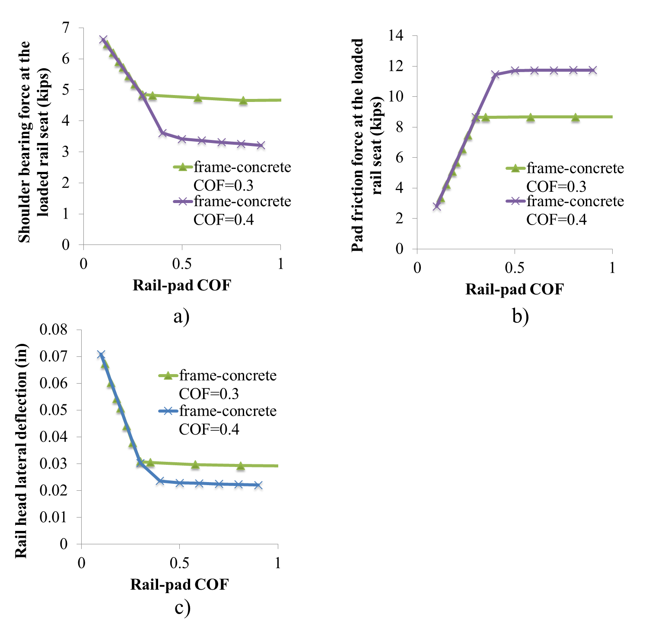

Figure 13. Results From Two-variable Parametric Studies Focusing on a) Shoulder Bearing Force, b) Rail Pad Friction Force, and c) the Rail Head Lateral Deflection

The two lines in each figure included in **Figure 13** indicate the cases with different frame-concrete COF. Each line represents a case of varying rail-pad COF within the defined range. In **Figure 13**, the relationship between different responses and varying COF was similar to the behavior shown in **Figure** **12**. In addition, the slopes of the two lines changed at different COF magnitude, which were 0.3 and 0.4, respectively. The location of different thresholds agreed with the frame-concrete COF of the cases, which support the assumption stated earlier. When the rail-pad COF was lower than the frame-concrete COF, it governed the system response, and identical response was observed between cases of different frame-concrete COF. However, when the rail-pad COF exceeded the frame-concrete COF, the frame-concrete COF governed the system response, which was not sensitive to the change of rail-pad COF. Considering this effect, the rail-rail pad COF and frame-concrete COF were combined into one variable, and identical COF were defined at the two interfaces for further parametric study.

* 1. *Determination of Critical Input Interaction*

To determine the input interactions that were statistically significant, the field-validated FE model was used to run model iterations that were generated using a full factorial design. In total, four input variables were included in the parametric study under each loading scenario, and 48 cases (24 * 3 = 48) were generated. Two levels were considered for each input variable, representing its minimum and maximum value.

After the cases were generated, the statistical software R (Venables et al. 2002) was used for ANOVA. A statistical model was built for each output, and through an ANOVA, p-values (Walpole et al. 1993) were calculated for each input variable and its interactions. Lower p-values indicate that the corresponding input or input interaction is more statistically significant for a certain output, and the threshold p-value to study the input interaction was determined as 0.05 (Walpole et al. 1993). In addition, the statistical models were built considering the hierarchy of variables (Faraway 2002). The input variables were defined as factorial, and they were first introduced in the statistical model without their interaction terms. Based on the result of ANOVA, input variables with a p-value larger than 0.05 were deemed insignificant and were removed from the model. After this step, only the second-order interactions of existing input variables were added to the model and tested for significance. After the insignificant terms were removed from the statistical model, higher-order interaction terms were added until all of the combinations were exhausted.

The results of ANOVA for the three loading scenarios are summarized in **Table 6**. The p-values of significant interactions are marked in bold. Some p-values were left blank as the corresponding input or lower-order input interaction was not significant for the given output. It can be observed that all of the second-order interactions of input variables were significant for at least one of the outputs, and none of the third-order interactions were significant to any of the output. The elastic modulus of the insulator and its interaction with other input were not included as they were not statistically significant for any of the four outputs. Considering this result, more cases were generated to investigate all of the second-order interactions of the three input variables.

Table 6. ANOVA Results for Three Loading Scenarios

|  |  |  |  |  |
| --- | --- | --- | --- | --- |
| Loading Scenario 1 | | | | |
| Vertical load = 40 kips, Lateral load = 10 kips | | | | |
| Interaction | P-value | | | |
| Rail head lateral deflection | Shoulder bearing force | Rail pad frictional force | Vertical rail seat load |
| Spacing:COF | 2.5E-01 | 1.1E-01 | **3.7E-02** | **4.0E-03** |
| Spacing:Pad modulus | **4.9E-04** | **4.6E-03** | **7.1E-04** | 1.6E-01 |
| COF:Pad modulus | **4.8E-06** | **6.7E-07** | **3.7E-10** | **2.0E-03** |
| Spacing:COF:Pad modulus | N/A | N/A | N/A | N/A |
| Loading Scenario 2 | | | | |
| Vertical load = 40 kips, Lateral load = 20 kips | | | | |
| Interaction | P-value | | | |
| Rail head lateral deflection | Shoulder bearing force | Rail pad frictional force | Vertical rail seat load |
| Spacing:COF | **1.3E-04** | N/A | N/A | **7.0E-05** |
| Spacing:Pad modulus | **1.6E-03** | N/A | N/A | 4.7E-01 |
| COF:Pad modulus | **5.1E-06** | **4.2E-06** | **6.7E-06** | **3.5E-09** |
| Spacing:COF:Pad modulus | 7.7E-02 | N/A | N/A | N/A |
| Loading Scenario 3 | | | | |
| Vertical load = 40 kips, Lateral load = 30 kips | | | | |
| Interaction | P-value | | | |
| Rail head lateral deflection | Shoulder bearing force | Rail pad frictional force | Vertical rail seat load |
| Spacing:COF | **4.4E-08** | N/A | N/A | **3.6E-07** |
| Spacing:Pad modulus | **1.7E-04** | N/A | N/A | 7.9E-01 |
| COF:Pad modulus | **4.2E-06** | **2.2E-10** | **4.1E-06** | **1.2E-12** |
| Spacing:COF:Pad modulus | 1.9E-01 | N/A | N/A | N/A |
| Spacing: Concrete crosstie spacing COF: The coefficient of friction at the rail-pad interface and the frame-concrete interface Pad modulus: The elastic modulus of rail pad | | | | |

SECTION 4 CONCLUSIONS

This chapter summarizes the research described within this report, highlights its contributions, and proposes directions for future research.

*4.1 Summary*

This study has addressed two primary objectives:

1. A comprehensive literature review was conducted in the area of lateral track load distribution, and detailed Finite Element (FE) models were developed for each component in the track system, including: fastening system, crosstie, rail, wheel, and substructure. These FE models were also coupled together and can be used to analyze track system behavior. The developed concrete crosstie and fastening system models can be a useful tool to ensure the serviceability and safety of rail infrastructure, and a means to further the state of art of track infrastructure design.
2. Parametric analysis was performed with the developed multiple-tie model with the aim of understanding the effect of various track components on the distribution of lateral loads between multiple crossties. This helps address some of the most pressing needs faced by the current U.S. railroad industry.

*4.2 Future Research Directions*

The present research addressed the problem of lateral load distribution in the track system. Future research can be conducted in a number of directions; some examples are listed as follows.

1. Develop a FE model to exam the interaction between track loading in vertical, lateral, and longitudinal direction.
2. Develop approach to optimize infrastructure component design based on the parametric analysis result from this study.

REFERENCES

Du, M.M., X.Z. Su and Y. Zhao. 2010. Experimental study on bond behavior of ribbed bar and strand. Jianzhu Cailiao Xuebao - Journal of Building Materials 13 (2): 175-181.

Ertzibengoa, D., S. Matthys and L. Taerwe. 2012. Bond behaviour of flat stainless steel rebars in concrete. Materials and Structures 45 (11): 1639-1653.Friedrich, K. 1986. Friction and wear of polymer composites, Elsevier.

Faraway, J.J. 2002. Practical regression and ANOVA using R. University of Bath.

Filho, A., F. Menezes, M.K. El Debs and A.L.H.C. El Debs. 2007. Bond-slip behavior of self-compacting concrete and vibrated concrete using pull-out and beam tests. Materials and Structures 41 (6): 1073-1089. Dassault Systemes Simulia Corp. 2011. ABAQUS Analysis User's Manual: Version 6.11. Dassault Systemes Simulia Corp.

Gambarova, P.G., and G.P. Rosati. 1996. Bond and splitting in reinforced concrete: Test results on bar pull-out. Materials and Structures/Materiaux et Constructions 29 (189): 267-276.

Huang, H., and E. Tutumluer. 2011. Discrete Element Modeling for fouled railroad ballast. Construction and Building Materials 25 (8): 3306-3312.

Harper, C.A. 1996. Handbook of Plastics, Elastomers, and Composites. McGraw-Hill Inc 2 (2): 41.

Hepburn, C. 1982. Polyurethane elastomers, Applied Science Publishers, London, England.

Kernes, R.G., J.R. Edwards,M.S. Dersch, D.A. Lange and C.P.L. Barkan. 2012. Investigation of the Dynamic Frictional Properties of a Concrete Crosstie Rail Seat and Pad and its Effect on Rail Seat Deterioration (RSD). In: Proceedings: 91st Annual Meeting of the Transportation Research Board, Washington, D.C., January 2012.

Kish, A. 2011. On the fundamentals of track lateral resistance. American Railway Engineering and Maintenance of Way Association.

Mitchell, D.W. and H. Marzouk. 2007. Bond characteristics of high-strength lightweight concrete. ACI Structural Journal 104 (1): 22-29.

Selig, E.T. and D. Li. 1994. Track modulus: its meaning and factors influencing it. Transportation Research Record (1470): 47-54.

Venables, W.N., D. M. Smith and R.D.C. Team. 2002. An Introduction to R: Notes on R: a Programming Environment for Data Analysis and Graphics: Version 1.4.1. Network Theory Limited.

Walpole, R. E., R.H. Myers, S.L. Myers, and K. Ye. 1993. Probability and statistics for engineers and scientists, Macmillan, New York, NY.

Wang, W. J., P. Shen, J.H. Song, J. Guo, Q.Y. Liu, and X.S. Jin. 2011. Experimental Study on Adhesion Behavior of Wheel/Rail under Dry and Water Conditions. Wear 271: 2699-2705.

Yamaguchi, Y. 1990. Tribology of Plastic Materials: Their Characteristics and Applications to Sliding Components, Elsevier Science.